ENHANCEMENT OF BANDWIDTH OF PLANAR MICROSTRIP
ANTENNA WITH METAMATERIALS

Ahmed Al-Shaheen
College of Medicine- Misan University-Maysan-Iraq
E-Mail: ahabood67@yahoo.com

ABSTRACT
In this paper we present a planar left-handed material pattern on the rectangular patch antenna mounted on the substrate is designed to enhance its horizontal radiation as well as to broaden its working bandwidth. The parametric study is done to study the effect of the ground plane slots width of 0.3, 0.4 and 0.5 mm respectively on the return loss and bandwidth enhancement, the best value of g is 0.4 mm. Enhancement in the bandwidth is achieved by introducing the metamaterial phenomena instead of the single patch antenna is about 19.2 times with g = 0.4 mm.

Keywords: microstrip antenna, planar antenna, metamaterial, band width enhancement.

INTRODUCTION
Single patch microstrip antenna is having many disadvantages one of them is the low band width, many applications needs wide band and high gain. The common method to increasing band width is by increasing the height of the dielectric substrate while the other is to decrease the substrate dielectric constant.
The radiation phenomena in a metamaterial transmission line based on series capacitive gaps and Complementary Split Ring Resonators CSRRs periodically loading a host microstrip line and acting as a leaky-wave antenna. The analysis performed for different distances between CSRRs and the substrate edges shows that in narrow substrates destructive interference occur between free space leaky wave radiation and surface wave modes, reflected at substrate edges [1]. Design using planar-patterned metamaterial concepts is used to proposed a planar microstrip antenna of metal patch and finite ground plane form a coupled capacitive-inductive (C-L) circuit of negative index metamaterial, to get an good performances for the proposed antenna in wideband, high efficiency, low loss and low VSWR. Finally, the proposed antenna is used to design Meta array [2-3].
A broadband planar antenna, which is composed of a dipole and six Lift Handed Material LHM unit cells, is demonstrated in [4]. The antenna is matched to 50 W with the stepped impedance transformer and rectangular slot in the truncated ground plane. By the utilization of phase compensation and coupled resonance feature of LHMs, the narrowband dipole antenna is operated at broader bandwidth. The zeroth-order resonant antenna has attracted great interest in that a metamaterial-based transmission line at a transition frequency with open or short terminations can have resonance phenomena regardless of its length and function as a very small radiator, a compact one-unit-cell antenna realized on a microstrip line is presented. The size of the proposed antenna is only 6  13.5 mm (or 0.05  0.13l0) at 2.7 GHz owing to zeroth-order resonance [5]. A compact antenna is important for today’s mobile communication systems. The difficulties when designing compact antennas encountered such as narrow bandwidth, impedance matching to a low radiation resistance, and low radiation efficiency. In [6] a wideband and compact planar antenna is proposed using a doubly resonant transmission-line Metamaterial (TL-MTM) structure. The proposed antenna consists of two TL-MTM arms that resonate at different frequencies. Each arm comprises a microstrip transmission-line loaded with five spiral inductors and is well matched to 50  and each arm is designed to work as a single antenna at its own resonant frequency.
Proposed a high-directivity antenna using a new type of two-layer Zero Index Metamaterial ZIM structure. The design of a ZIM structure based on the unit cell simulation present in [7]. Metamaterials, also known as left-handed metamaterial (LHM) where the permeability and permittivity were simultaneously negative. LHM is an interesting material to be investigated where this artificial material has several unique properties such as the backward wave and the focusing effect inside it slab, the design and simulation of the left-handed metamaterial structure incorporated with a single microstrip patch antenna is present in [8]. The combination of the modified square rectangular split ring (SRR) and the capacitance loaded strip
(CLS) was used to obtain the negative value of permeability, μr and the negative permittivity, r, the gain of the antenna has been increased up to 4 dB. This had proven that the LH MTM can enhance the gain of the antenna [8].
Design of the metamaterial based microstrip antenna with the ground slots is proposed for gain-enhanced dual-band operation. To realize the dual-band operation of the left-handed and the zero-order resonant mode, six equilateral triangular patches which are consists of the coupling gap and the through-hole via are isotropic arranged and the feeding structure is wired to one patch [9]. Metamaterials are artificial materials that allow the occurrence of simultaneously negative permeability and permittivity, hence sometimes called double negative (DNG). In [10], the effect of metamaterials on a cylindrical-rectangular microstrip patch antenna loaded with a superstrate. A layer of metamaterial is inserted between the substrate and the superstrate. The analysis is carried using the electric surface current method (ESCM) and results are presented as plots of the radiation pattern in the far field for different negative values of the permeability and permittivity. The effect of an air gap has also been investigated also [10].
Metamaterials can be used to enhance Antenna Bandwidth. To this purpose, a particular Metamaterial cell is introduced in [11] for which its design parameters are detailed. This cell is then used to enhance the performances of a microstrip antenna which can be found in communication systems. As wireless communications applications continue to require more and more bandwidth, there has been continued increase in demand for ultra-wide bandwidth antennas. Planar monopole antennas are generally suitable for mobile applications and hence we researched avenues to improve the bandwidth of this antenna structure. The proposed antenna design in [12] provides an impedance bandwidth (S]] <-10dB) of more than 29GHz corresponding to over 900% increase over the original bandwidth. In [14] four multi-frequency circularly polarized antennas are proposed. The first one is a 4-ports selfdiplexed multi-frequency right hand circularly polarized RHCP- left hand circularly polarized LHCP antenna. The second antenna is a single-feed short-circuited circular patch antenna filled with metamaterial structures to obtain a single port circularly polarization antenna. The two last antennas proposed are conventional microstrip patch antennas filled with metamaterial structures, with some modifications in order to achieve the desired circularly polarization using only one port. Finally, both, dual-feed and single-feed configurations are compared [14].
In this paper we present a planar left-handed material pattern on the rectangular patch antenna mounted on the substrate is designed to enhance its horizontal radiation as well as to broaden its working bandwidth via its coupling with the conducting ground backed to the substrate and patterned in a different way. On the upper patch, the periodic gaps are designed in the form of isolated micro-rectangles.

ANTENNA GEOMETRY
Figure-1 shows the proposed antennas, the antenna consist of the patch antenna formed from the periodic cell each one consist of small rectangles and gaps mounted on substrate of Douriod of 2.2 dielectric constant. The geometry dimensions are listed in Table-1.

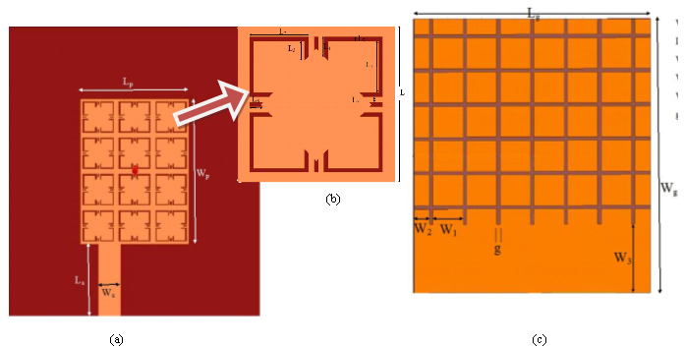

Figure-1. Antenna geometry (a) front of antenna, (b) unit cell, and (c) back of antenna.

SIMULATION RESULTS
To investigate the performance of the proposed antenna the, the antenna has been design and simulating using High frequency structure simulation HFSS with two different approaches using Finite element method FEM and Integral Equation IE solver, to insure the validity of the proposed antenna Figure-2 show that. To investigate the bandwidth enhancement, the traditional rectangular patch antenna of the same dimensions for the patch, ground plane, and the microstrip feed line, with the same substrate properties (i.e., height and dielectric constant) is used to compared the simulating results. The parametric study is done to study the effect of the ground plane slots width of 0.3, 0.4 and 0.5 mm respectively on the return loss and bandwidth enhancement. Figure-3 demonstrates the return loss of the proposed antenna as a function of the ground plane slot width in the frequency range 1 GHz to 20 GHz.

Table-1. Antenna parameters all dimensions in mm.

Parameter | Value | Parameter | Value | Parameter | Value | Parameter | Value
L_{p} | 12 | L₁ | 1.3 | L₆ | 0.34 | W₂ | 0.18
W_{p} | 16 | L₂ | 1.5 | L₇ | 0.1 | W₃ | 8
L_{s} | 8 | L₃ | 0.49 | L_{g} | 28 | G | 0.4
W_{s} | 2.46 | L₄ | 0.49 | W_{g} | 32 | H | 0.974
L | 4 | L₅ | 0.15 | W₁ | 0.36 | ε_{r} | 2.2

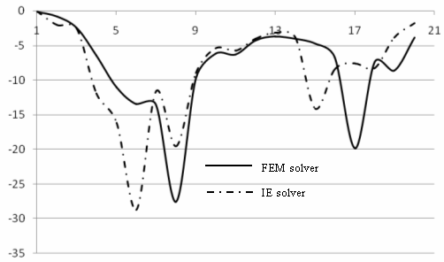

Figure-2. Return loss of the proposed antenna with tow different solvers FEM and IE.

The results investigating from the Figure-3 is depicted in Table-2. The single antenna is simulating to computing the return loss and the resonance frequency in the same operating band, the result is shown in the Figure-4. One can find that the main resonant frequency is 7.826 GHz with two bandwidths are 0.225 GHz and 0.473 GHz respectively. As shown from Figure-3, Figure-4 and Table-2 the enhancement in the bandwidth is about 18.64, 19.2, and 18.76 times. Figure-5 is the radiation pattern in the E-plane and H-plane of the single antenna, while Figure-6 is demonstrating the radiation pattern of the proposed antenna for the three resonant in the E-plane and H-plane.

Table-2. Bandwidth and resonances frequency of the proposed antenna.

g (mm) | Bandwidth (GHz) | Resonance frequency (GHz)
g (mm) | Bandwidth (GHz) | Band 1 | Band 2
0.3 | 4.195 | 8.095 | 16.495
0.4 | 4.320 | 8.113 | 16.945
0.5 | 4.220 | 8.122 | 17.290

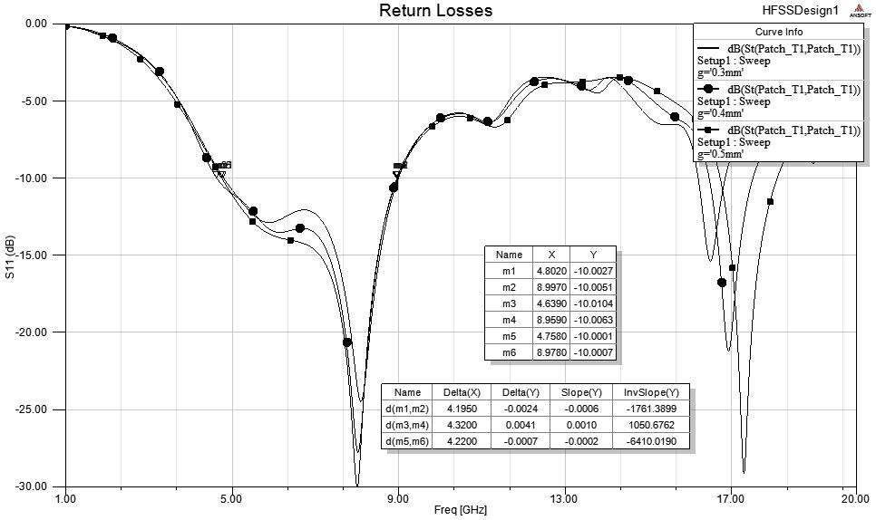

Figure-3. Return loss of the proposed antenna versus ground plane slot width g.

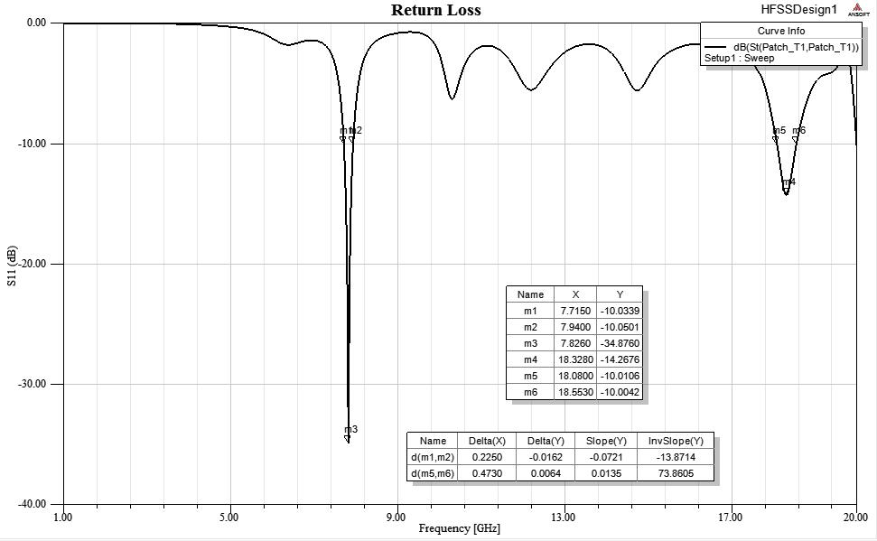

Figure-4. Return loss of the single antenna

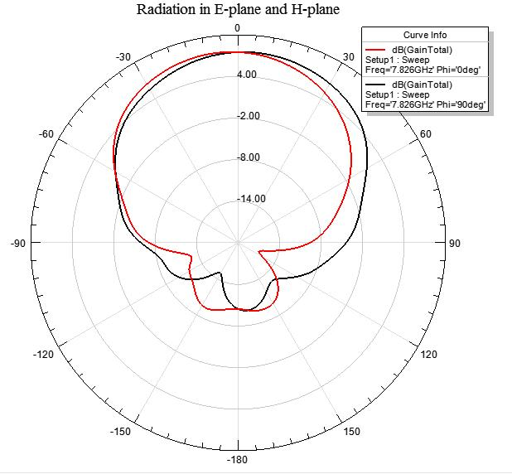

Figure-5. Radiation pattern of the single antenna in E-plane and H-plane.

(a)
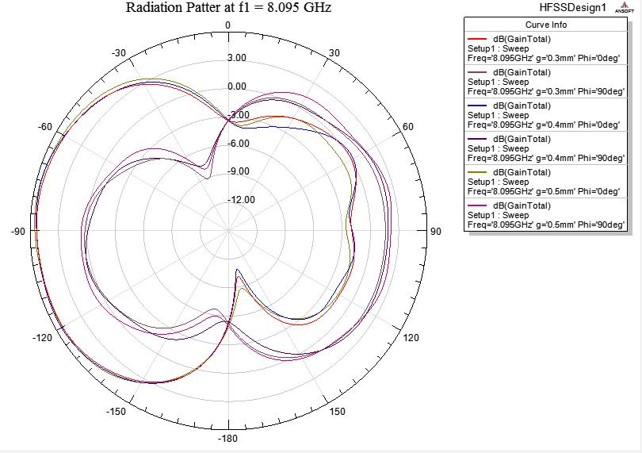

(b)
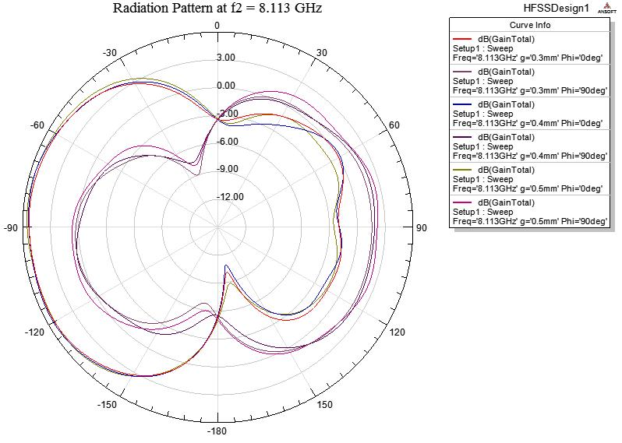

(c)
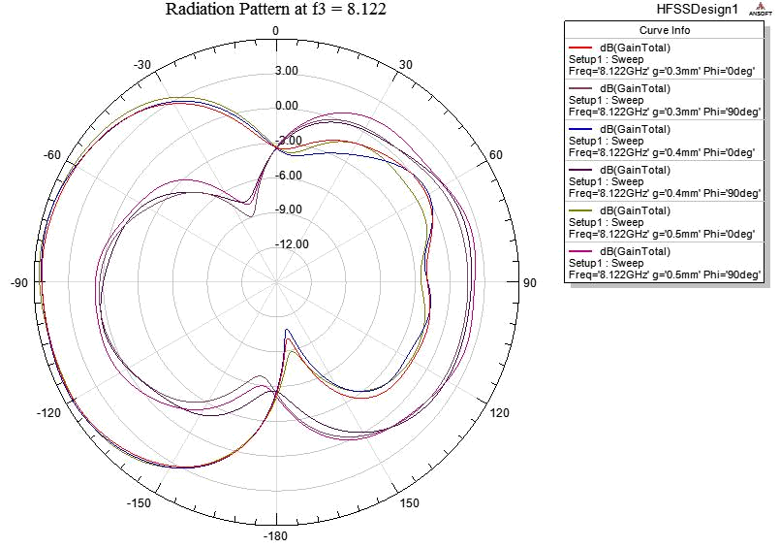

Figure-6. Radiation pattern of the proposed antenna in E-plane and H-plane at (a) 8.095 GHz,
(b) 8.113 GHz and (c) 8.122 GHz.

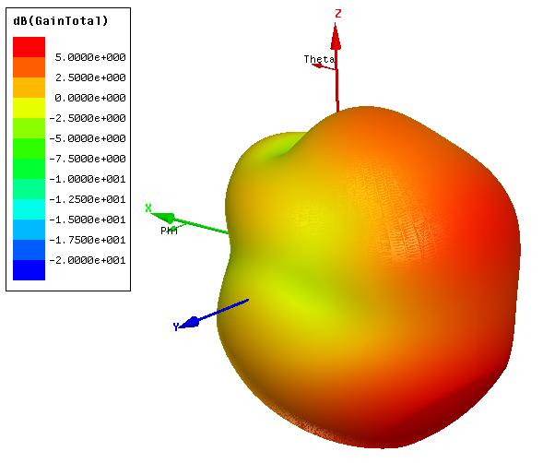
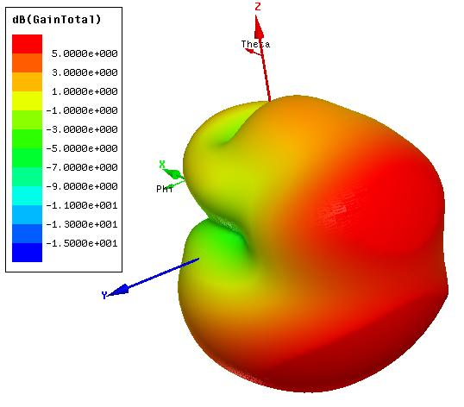
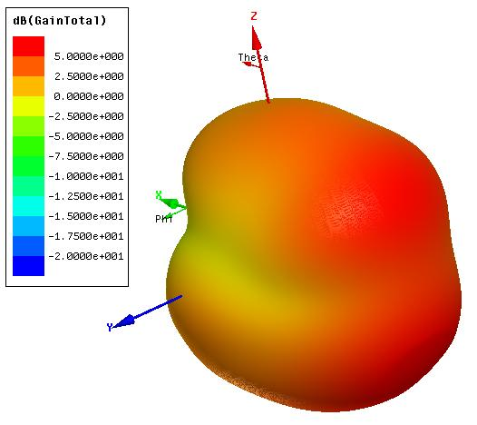
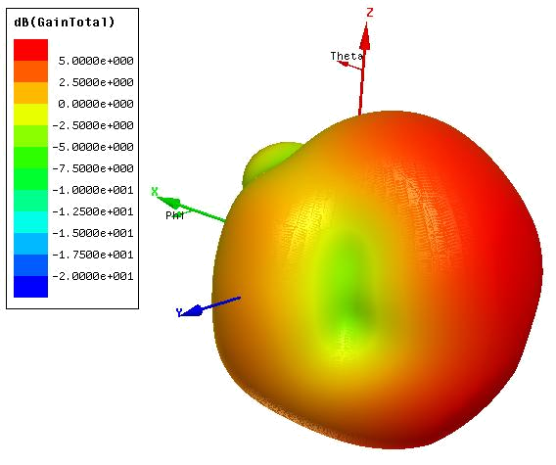
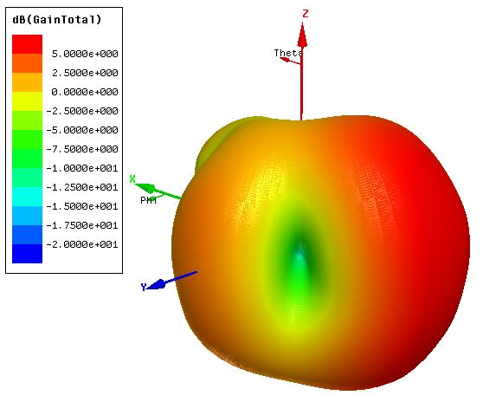
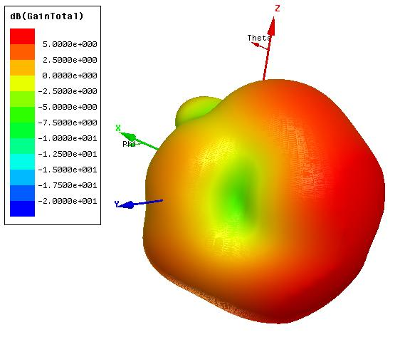

f = 8.095 GHz g = 0.3 mm g = 0.4 mm g = 0.5 mm

f = 8.113 GHz g = 0.3 mm g = 0.4 mm g = 0.5 mm

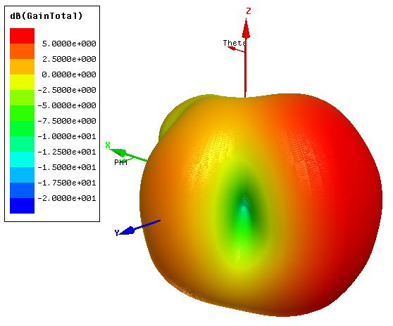
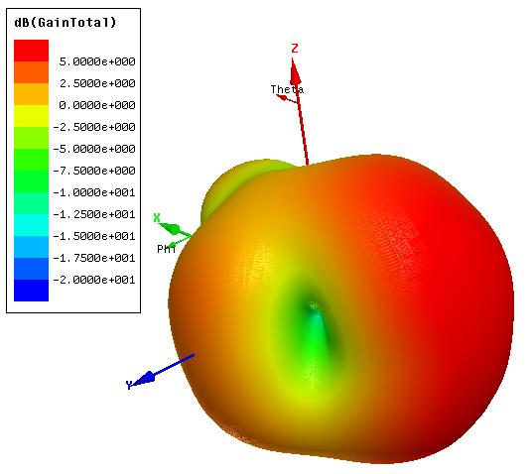
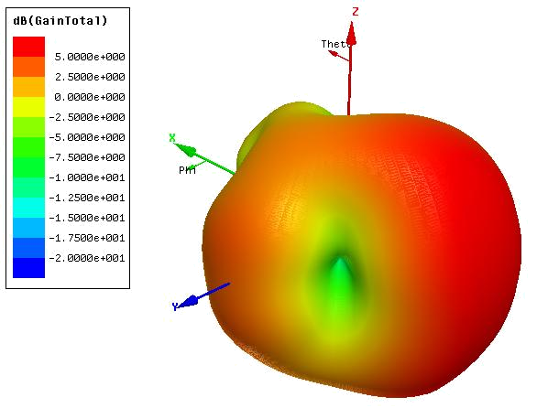

f = 8.122 GHz g = 0.3 mm g = 0.4 mm g = 0.5 mm

Figure-7. Radiation pattern of the proposed antenna in E-plane and H-plane at 8.095 GHz, 8.113 GHz and 8.122 GHz versus ground plane slots g.

The total gain versus frequency range as a function of the ground plane slot width g is illustrated in Figure-8.

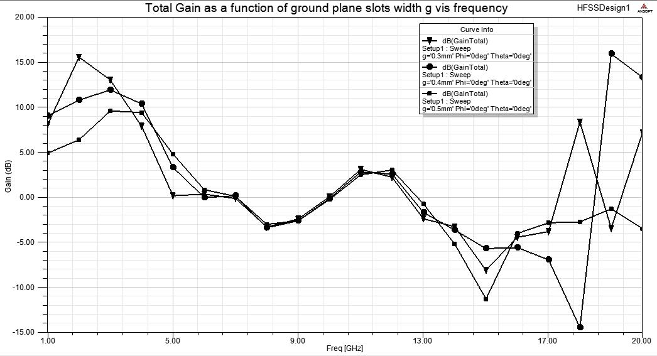

Figure-8. Total gain of the proposed antenna in the frequency range versus ground plane slots g.

CONCLUSIONS
In this paper we present a planar left-handed material pattern on the rectangular patch antenna mounted on the substrate is designed to enhance its horizontal radiation as well as to broaden its working bandwidth, we validate our proposed design by comparing tow different methods as shown in Figure-2. The parametric study is done to study the effect of the ground plane slots width of 0.3, 0.4 and 0.5 mm respectively on the return loss and bandwidth enhancement, the best value of g is 0.4 mm. Enhancement in the bandwidth is achieved by introducing the metamaterial phenomena instead of the single patch antenna is about 19.2 times with g = 0.4 mm.

REFERENCES

- S. Eggermont and I. Huynen. 2010. Substrate Edge Effects in Leaky Wave Antenna Based on Complementary Split Ring Resonators. Proceedings of the Fourth European conference on antenna and propagation.

- Le-Wei Li, Ya-Nan Li and Ke Xiao. 2010. Broadband and High-Gain Metamaterial Microstrip Antenna Arrays. Proceedings of the Fourth European conference on antenna and propagation.

- Le-Wei Li, Ya-Nan Li, Tat Soon Yeo, Juan R. Mosig and Olivier J. F. Martin. 2010. A broadband and high-gain metamaterial microstrip antenna. Appl. Phys. Lett. 96, 164101.

- M. Palandoken, A. Grede, and H. Henke. 2009. Broadband Microstrip Antenna with Left-Handed Metamaterials. IEEE transaction on antennas and propagation. 57(2): 331-338.

- T.-G. Kim and B. Lee. 2009. Metamaterial-based compact zeroth-order resonant antenna. Electronics letters. 45(1).

- J. Zhu and G. V. Eleftheriades. 2009. A Compact Transmission-Line Metamaterial Antenna with Extended Bandwidth. IEEE antennas and wireless propagation letters. 8: 295-298.

- H. Zhou, Z. Pei, S. Qu, S. Zhang, J. Wang, Z. Duan, H. Ma, and Z. Xu. 2009. A Novel High-Directivity Microstrip Patch Antenna Based on Zero-Index Metamaterial. IEEE antennas and wireless propagation letters. 8: 583-541.

- H. A. Majid, M. Kamal A. Rahim and T. Masri. 2008. Left handed metamaterial design for microstrip antenna application. Proceedings of IEEE International RF AND Microwave Conference. 2008, 218-221, Kuala Lumpur, Malaysia.

- S. Pyo, M. Lee and Y. Kim. 2010. Metamaterial-Based Microstrip Antenna with Ground Slots for Gain-Enhanced Dual-Band Operations. 2010 URSI International Symposium on Electromagnetic Theory. pp. 926-929.

- R. S. Salama and R. Liyana-Pathirana. 2010. Analyzing the Effect of Metamaterials on a Cylindrical-rectangular Microstrip Patch Antenna Using the Electric Surface Current Method. International conference on signal processing and communications (SPCOM). 2010. 978-1-4244.

- H. Griguer, E. Marzolf, H. Lalj, F. Riouch and M. Drissi. 2009. Patch antenna Bandwidth Enhancement through the use of metamaterials. International conference on telecounnications. pp. 323-327.

- D. Nashaat, H. A. Elsadek, E. Abdallah, H Elhenawy and M.F. Iskander. 2009. Enhancement of Ultra-Wide Bandwidth of Microstrip Monopole Antenna by Using Metamaterial Structures. IEEE antenna and propagation international symposium. 978-1-4244.

- E. Ugarte-Muñoz, F. Javier Herraiz-Martínez, V. González-Posadas Muñoz. and D. Segovia-Vargas. 2009. Design Techniques for Circularly Polarized Antennas using Metamaterial Structures. Proceedings of the 39th European Microwave Conference. pp. 630-633.

